Ideation Phase
Brainstorm & Idea Prioritization

Date | 05 Apr. 26
Team ID | SWTID-2026-7295
Project Name | Smart Library Request Workflow in ServiceNow
Maximum Marks | 4 Marks

Brainstorm & Idea Prioritization:
Brainstorming provides a free and open environment that encourages everyone within a team to participate in the creative thinking process that leads to problem solving. Prioritizing volume over value, out-of-the-box ideas are welcome and built upon, and all participants are encouraged to collaborate, helping each other develop a rich amount of creative solutions.

Step-1: Team Gathering, Collaboration and Select the Problem Statement
How might we build a backend system in ServiceNow that automates book requests and ensures secure, role-based access for students and librarians?
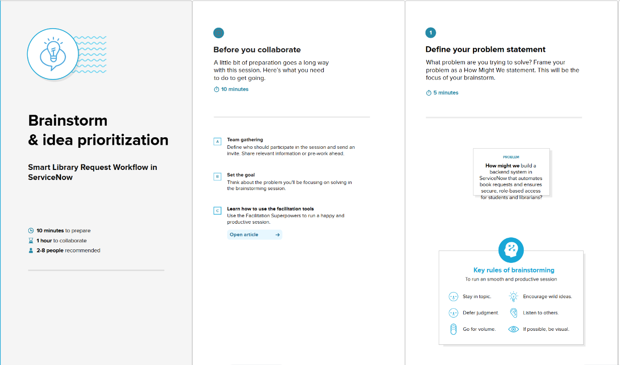

Step-2: Brainstorm, Idea Listing and Grouping
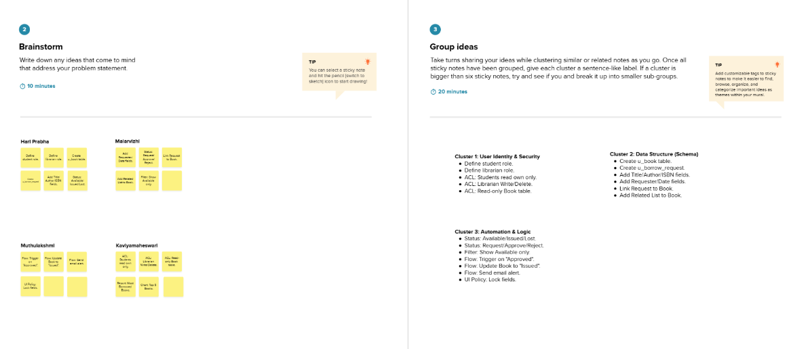

Step-3: Idea Prioritization
